Book Review by: _____________________________

Date: ______________________ Tutor group: ______________________

Title:

Author:

My star rating for this book:



Plot: How does the story start? The middle? Don’t give away the end!

Characters & Setting: Who is your favourite character and why? Where does the story take place?

Opinion: What was your favourite part of the story and why?

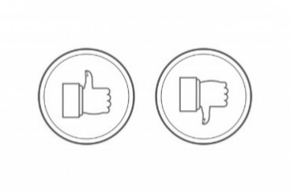Would you recommend this book? Why/why not?